1. Add a variable name **age** to class **Player and its constructor**

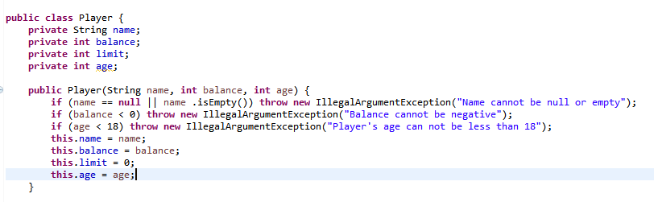

1. Test the resolution by JUnit Test

